Saxion International Week 2014



Date: 17-21 March 2014

Location : Saxion Enschede, The Netherlands

Theme: “Global business: opportunities and challenges in a changing world”

Dear students,

Welcome to the Saxion international week! We are going to offer you an inspiring programme, exciting meetings with students from all over Europe and a cosy social programme.

We have 3 lodging options for you during the week. They are all located at the Campus of the Twente University in Enschede. All locations are on walking distance from each other.

For the options B and C are only a limited number of rooms available. Allocation will on basis of first come first served.

Mark your choice on the registration form!

Application deadline : 15 January 2014

Saxion UAS
School of Business, Building and Technology
M.H. Tromplaan28 | Handelskade 75
7513 AB Enschede | 7417 DH Deventer
Info and registration: Maria Caliskan
E: m.caliskan@saxion.nl
T: +31 (0)570 603 911

Tentative programme:

Monday 17 March:
Morning: Arrival of guests
Afternoon: Plenary opening sessions
Evening: Reception and walking buffet dinner

Tuesday 18 March
Morning: Workshop sessions
Afternoon: Workshop sessions
Evening: Students programme

Wednesday 19 March
Morning: Human Resource Management
Afternoon: Excursion
Evening: Students programme

Thursday 20 March
Morning: Workshop sessions and study abroad fair
Afternoon: Workshop sessions
Evening: Students programme

Friday 21 March
Morning: Closing ceremony, presentation of the certificates for guest students.

Lodging facilities:
For the options B and C only a limited number of rooms are available. Allocation on basis of first come first served.
A: Basic lodging: Log Cabins at the University Twente Campus.
The log cabins ( heated ) accommodates 15 students in 2 rooms. Toilet and bathroom facilities are in a separate building.
Price 190 euro includes breakfast, sheets, blankets (but it is advised to bring your own sleeping bag as well), most meals, company visit, participation in the programme and transport to Saxion (bike)
Log cabins: http://www.utwente.nl/fb/reserveringen/en/blokhut/

B: Basic hotel: Logica at the University Twente Campus:
Two persons per room.
Price 260 euro includes breakfast, most meals, company visit, participation in the programme and transport to Saxion (bike)
Logica: http://www.drienerburght.nl/index.php?id=39&L=2

C: Hotel: Drienerburght at the University Twente Campus
Two persons per room.
Price 280 euro includes breakfast, most meals, company visit, participation in the programme and transport to Saxion (bike)
Drienerburg: http://www.drienerburght.nl/index.php?id=44&L=2

A: Basic lodging

Log Cabins at the University Twente Campus

€ 190,00

€ 20,00 cash deposit bike rental*

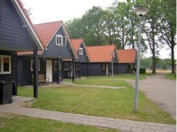

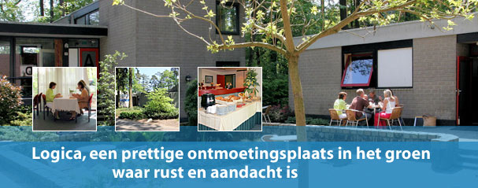
B: Basic hotel
Logica at the University Twente Campus
€ 260,00

€ 20,00 cash deposit bike rental *

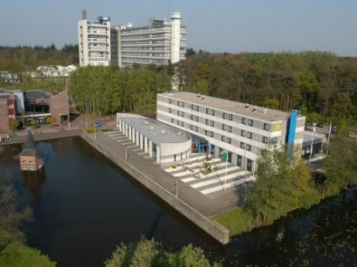
C: Hotel
Drienerburght at the University Twente Campus
€ 280,00
€ 20,00 cash deposit rental bike *

*The cash deposit will be returned after handing in the bike at the end of the week.

