# Dear colleague,

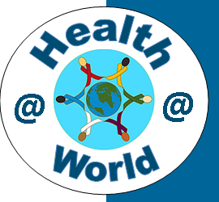**HOWEST University college West-Flanders is organizing its second international week in the bachelor in nursing with the title "Health@World", 24-28 March 2014.**

**We warmly invite lecturers and students to participate!**

**Tuition is free of charge, but the participants need to take care of their own travel and subsistence costs. (for teachers participation can be organized as Erasmus mobility)**

**Program Health@World**

International week in the nursing education of the University College of West-Flanders

As a future nurse it’s important to look at your own place within a more global and evolving context both national and international. Through this course, students learn to know the importance of social and cultural influences on nursing, health and health care and open their minds to the diversity of our society.

**Content**

During this course students will learn about the influence of Europa and the world (fex. Millennium goals of WHO) on health care (in Belgium).

Students will also learn to be sensitive for other cultures they meet in health care settings and learn how that influences the daily practice as a nurse.

**Goals**

The two content-topics mentioned above will give the nurse students a broad look at health care in the world. The nurse students will be(come) conscious  of the influence of cultural diversity and identity in the nursing practice.

**Program**

Monday 24/03/2014

**Registration, a guided visit of Bruges for the international guests**

All international guests need to register in the afternoon at HOWEST BRUGGE - CAMPUS RIJSELSTRAAT. The campus is at 5 minutes walk from the railway station of Bruges. Take the exit that leads to the back of the railway station of Bruges (Sint-Michiels). The Rijselstraat is now right in front of you. The campus can be found 200 meters further at the left side. Also check the map on [www.howest.be](http://www.howest.be).

**Bruges**

Bruges is the capital and largest city of the province of West Flanders in the Flemish Region of Belgium. It is located in the northwest of the country. The historic city center is a prominent World Heritage Site of UNESCO.

Tuesday 25/03/2014

**Nursing worldwide, welcome and meet & greet**

Evidence based nursing is becoming common practice in health care settings. Still there’s a lot of differences between the nursing practice in different countries worldwide and even in Europe.

Is nursing practice also cultural determined?

Both students and lecturers who’re participating in international exchange are reporting a lot of differences in nursing procedures, materials and practice between countries. Even within a country differences in nursing practice can already differ between health care settings (fex. hospital versus home care).

An important cause of these differences is definitely the environmental reality in witch nursing is practiced, but maybe also different evidence and therefore different nursing education. Maybe can even speak about a different ‘nursing culture’.

All participating lecturers bring a poster and/or documentation and demonstration material about a nursing practice.

Practical organization:

We invite all participating lecturers for a poster presentation and even demonstration of basic nursing practice or a basic nursing skill in their nursing education. For this year the focus is: injections (ID, SC, IM, IV).

Organized as an exhibition, all participating lecturers will get a table to put demonstrating materials and a wall to put a poster. Participating students will visit the different exhibitioners with a prepared questionnaire and will need to compare the nursing practice they discover with their own.

What follows is a discussion about the differences in nursing practice between the participants. This results in a joint paper (to be used freely by all participants).

During the meet & greet all participants present in brief their countries (health system and universities nursing education) in an informal setting with some music, refreshments and even some typical food. We invite participants to bring material with them.

Wednesday 26/03/2014

**Health (care) worldwide**

Many factors combine together to affect the health of individuals. Whether people are healthy or not, is determined by their circumstances (health behavior, genetics, …) and environment. To a large extent, factors on international (economic inequality north-south, financial crisis, …), national (debts, economic measures, …), community (environment, employment, …) and family (income, housing, …) level all have considerable impacts on health.

The different influencing factors mentioned above are presented to the first year students as a framework to be able to understand differences in health, health care and health behavior of different nationalities/cultures.

Guest lecturers give presentations about health (care) consequences of a globalized world and more specific the influence of Europe on the health (care) within the member states.

Thursday 27/03/2014

**Culture sensitive care**

An interactive workshop on intercultural communication focuses on the possible misunderstandings. People from different cultures encode and decode messages differently, increasing the chances of misunderstanding, so the safety-first consequence of recognizing cultural differences should be to assume that everyone's thoughts and actions are not just like ours. Such assumptions stem from potentially devastating ignorance and can lead to much frustration for members of both cultures.

Also in healthcare we meet patients from other cultures and misunderstandings in communication are possible. Zorgnet Flanders proposed recently an ethical paper with advice to health professionals about culture sensitive care.

We invite several health professionals for a testimony of how they bring the Zorgnet-paper into practice. Together with the participating nurse students we organize discussion tables to explore this paper and translate it to our nursing practice trough casework.

Friday 28/03/2014

**Visit of healthcare facilities in the Bruges area**

Different visits are planned, visit to the main university hospital in Bruges. We can also arrange visits to other health facilities on demand.

**Application**

Online information and application: <http://www.howest.be/Default.aspx?target=howest&lan=nl&item=1250>

(application deadline is 24 February 2014)

**Accommodation**

We propose the IBIS budget hotel, a new and cheap hotel situated next to the main entrance of the railway station of Bruges. Then you’re near to our campus and also near to the city center. Following this link you can find some information: <http://www.accorhotels.com/nl/hotel-5046-ibis-budget-brugge-centrum-station-previously-etap-hotel/index.shtml>.

Another possibility is the SNUFFEL Backpacker hostel. A character budget hostel without budgeting on friendliness, hospitality and great atmosphere, centrally located in the old part of town. Following this link you can find some information: <http://www.snuffel.be/>

**Guest lecturers**

Guest lecturers are warmly welcome to participate in the international week. The visit can be organized as an Erasmus teacher exchange.

We invite lecturers (from international partner institutions) for a **country presentation** (on Tuesday during the meet & greet) .

Furthermore we invite lecturers to bring a **poster and/or demonstration materials about the basic nursing skill:** administrating drugs by injection (ID, SC, IM, IV), comparing evidence, practice and education (on Tuesday during the exhibition and following discussion).

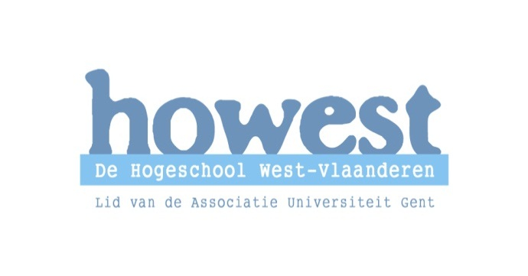If you need further information or you have questions or suggestions, don’t hesitate to contact:

Howest, University College West-Flanders

Rijselstraat 5 8200 Brugge (Belgium)

M +32 (0)498 11 24 38

[kurt.debaere@howest.be](mailto:kurt.debaere@howest.be)